The Bear
Name
Institution.
Date.

The Bear.
My day as an Adorable Teddy Bear named “Mrs. Ted”.
zzz!!! The winter is really cold, I would keep myself inside the sheets the day long.
Cold! Cold! Cold!, it’s unfortunate that I won’t stay outside for the entire day.

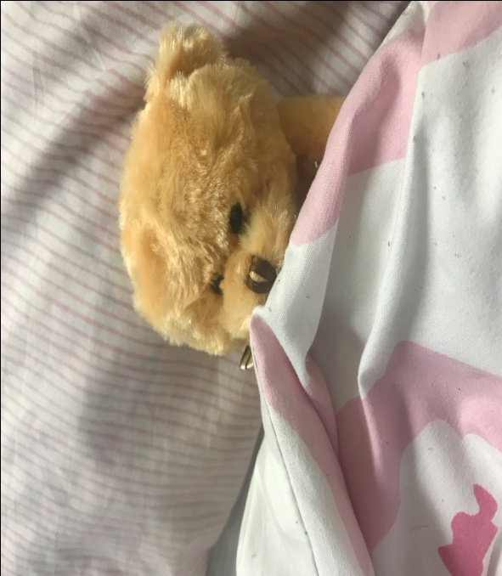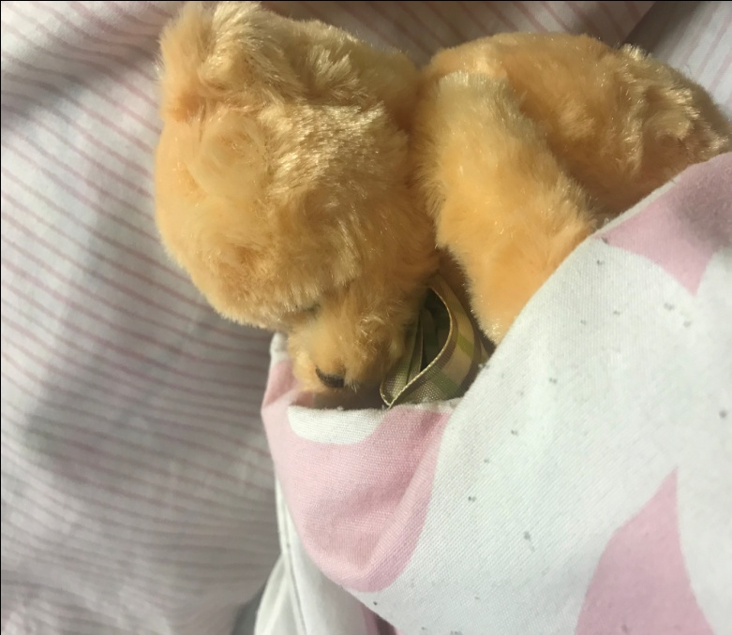
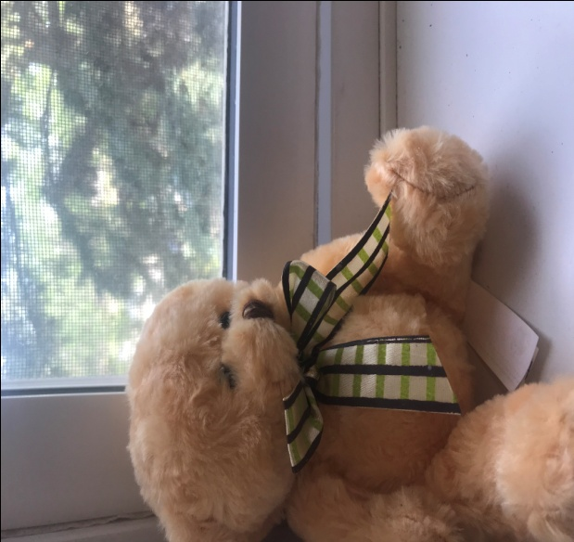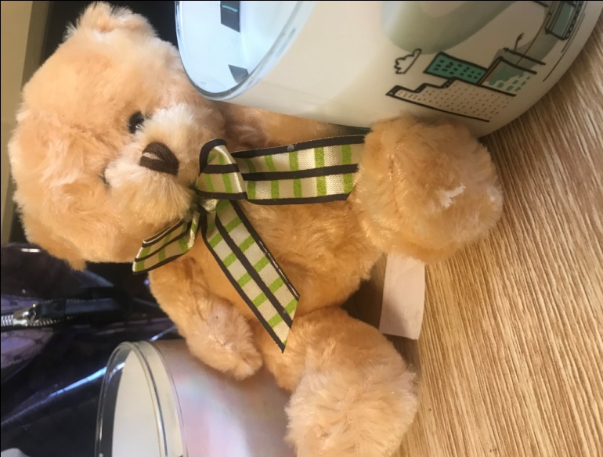
Oops: let me get some candle lit warmth
Oh my God!!The weather outside is even worse.
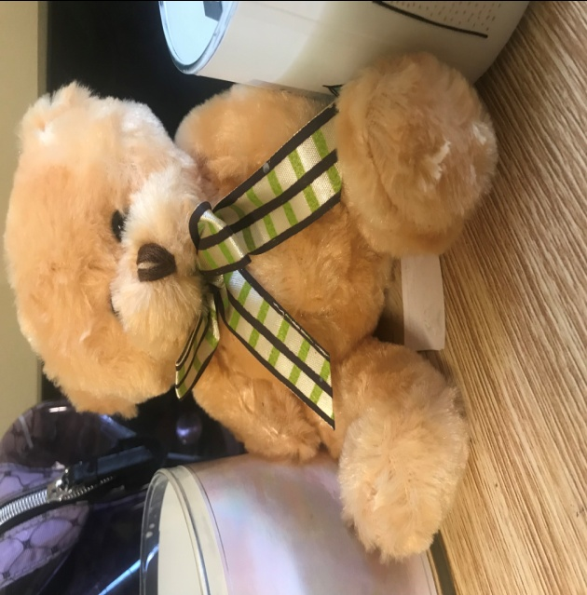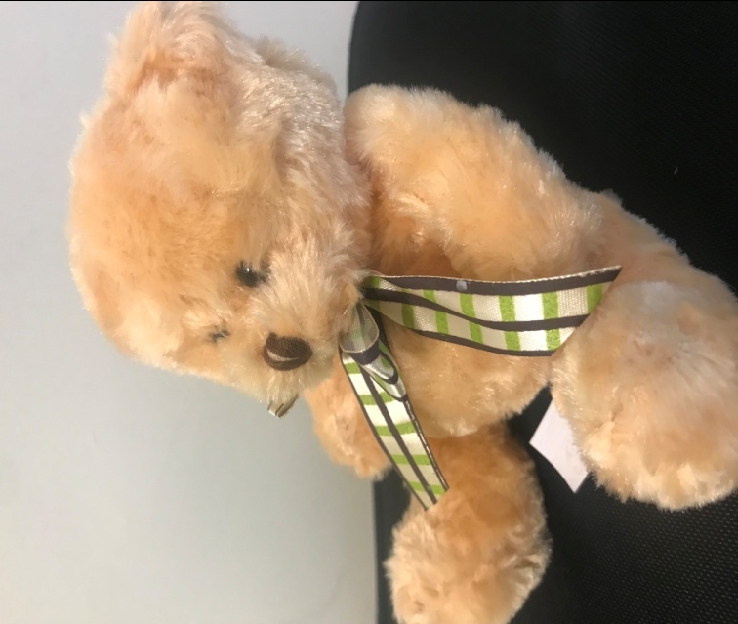
Oops!! My tummy feels empty, I have to feed as soon as possible.
Resting also makes my days, it is about time I make myself comfortable. THIS home is mine!!!
Alas!! It feels cold still, let me sit upright and

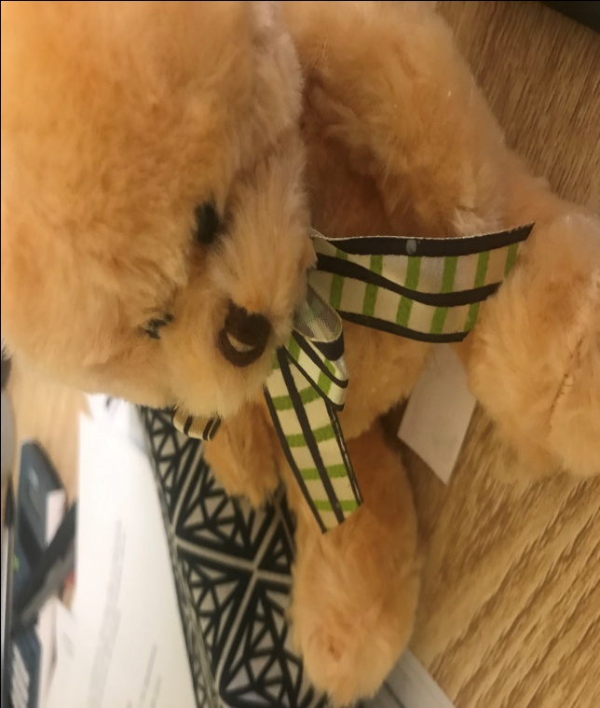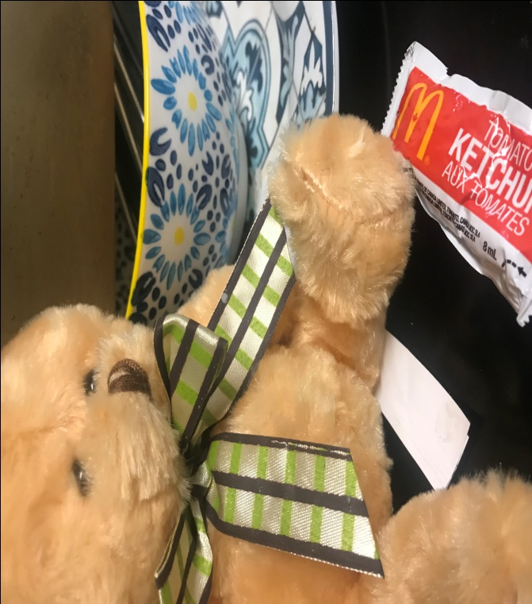
Oh my!!There is nothing to feed on in this house. This feels sad but my ketchup tomato sauce still works !! Poor Bear!!!
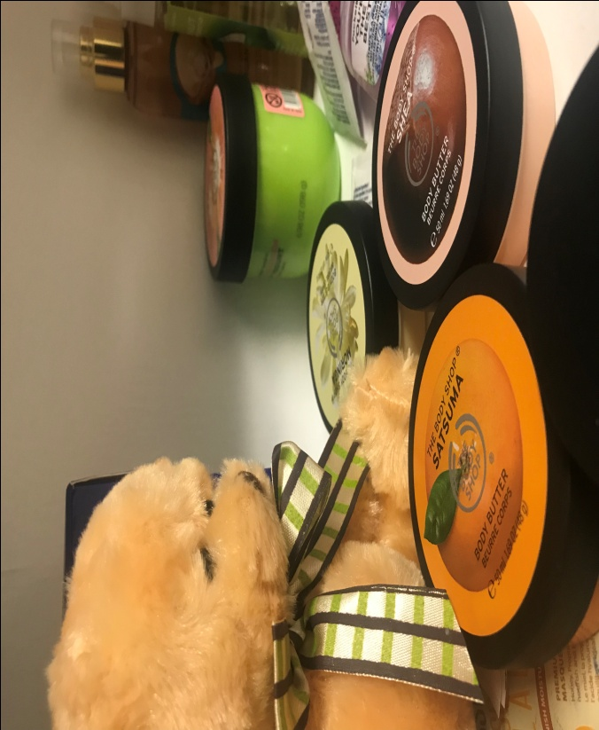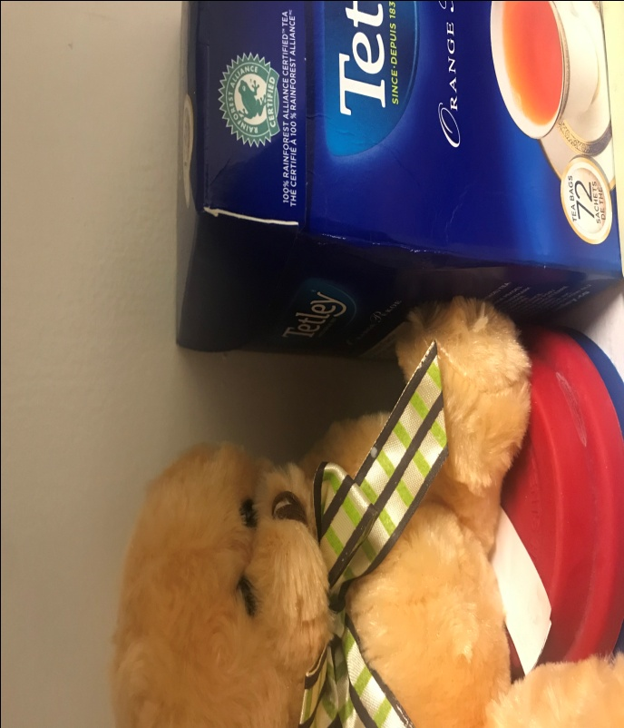
Hurray; I got a solution for the weather. I will make some Tetley Tea and I will be good to go. This is my favorite flavor. Yaaaaaaaaaaaaaaay!1!!
By the way, I also need to look good, my look is a priority, let me get my face makeup.
Narration.
My name is Mrs. Ted, the most adorable Teddy Bear in the neighborhood. It is the winter season, and the cold forces me to stay indoors to keep warm each day. I always lie on the seat while keeping warm, but such weather is discouraging as it does not allow me to step outside. Snow is everywhere, and as such, I have to put up with the reality that I will have to wait for the summer season to enjoy some sunlight. Besides covering myself using warm sheets, I also rely on warmth from the Chandelier and candles, and these seem to solve the cold problem partially. In such days, I also take enough rest and enjoy the comfort of my home as Mrs. Ted. The cold is, in most cases, devastating as it forces me to stay hungry for the whole day.In some cases, I am forced to consume tomato Ketchup to ease my hunger. I also like making myself appealing, and as such, I usually apply some makeup as part of my leisure time. At the end of the day, I prepare some Tetley tea, and this keeps me warm for some time. Frankly, I am so eager for the summer to come as winter seems to be very troublesome.
Français de la narration
Je m'appelle Mme Ted, L'Ours En Peluche le plus adorable du quartier. C'est la saison d'hiver, et le froid m'oblige à rester à l'intérieur pour garder au chaud chaque jour. Je m'allonge toujours sur le siège tout en me tenant au chaud, mais un tel temps est décourageant car il ne me permet pas de sortir. La neige est partout, et en tant que tel, je dois supporter la réalité que je vais devoir attendre la saison estivale pour profiter de la lumière du soleil. En plus de me couvrir avec des draps chauds, je me fie aussi à la chaleur du lustre et des bougies, et ceux-ci semblent résoudre partiellement le problème du froid. Dans ces jours-là, je me repose assez et je profite du confort de ma maison en tant que Mme Ted. Le froid est, dans la plupart des cas, dévastateur car il me force à rester affamé toute la journée.Dans certains cas, je suis forcé de consommer du ketchup tomate pour soulager ma faim. J'aime aussi me rendre attrayant, et en tant que tel, j'applique habituellement un peu de maquillage dans le cadre de mon temps libre. À la fin de la journée, je prépare un peu de thé Tetley, et cela me tient chaud pour un certain temps. Franchement, j'ai tellement hâte que l'été arrive, car l'hiver semble être très pénible.

